The following are the solutions for the Libram City Science District Power Plant Puzzle
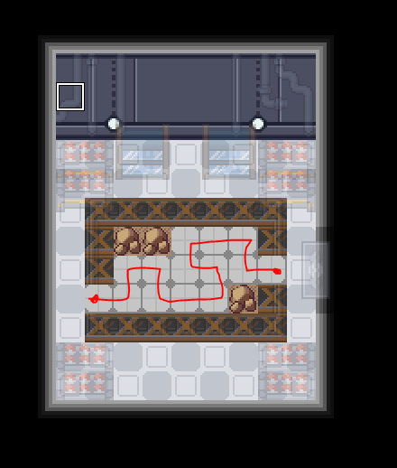

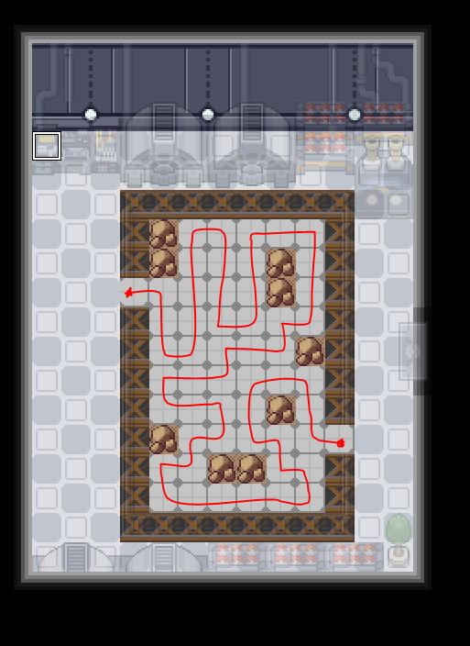
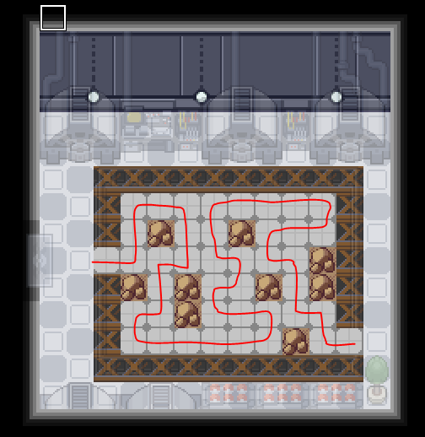

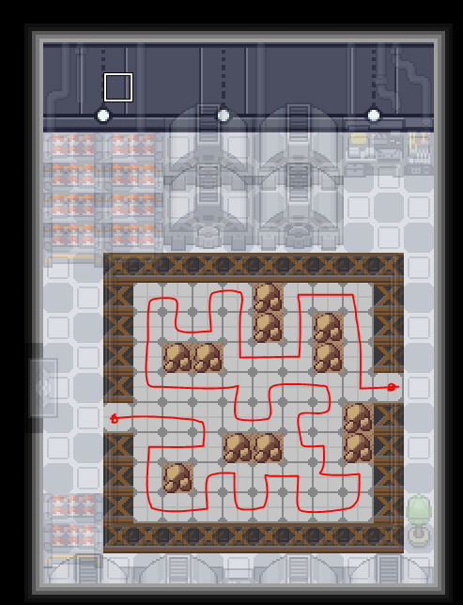

The following are the solutions for the Tucana Bayou Destroyed Lab Rotary Puzzle

**Ok so to summarize how to get to the boss**:
- We start at Exit, go to door 2 as it's the only available way.
- Take P1 rotary which forces you counterclockwise to door 3.
- Toggle C1 and then go back the way you came.
- P1 rotary now forces you counterclockwise up to the directional pads,
- You can then take P4 without any intervention required straight to 11, and you're done.
- If you hunt for items or quests, when you finish the story elements, all the rotary panels go away so you don’t need to switch anything on or off and you can walk the facility freely. If you want to do this before hitting up the boss, we've confirmed that all other parts of the facility are definitely accessible through a mix of toggling the different computers.
